WIFI BULB USE MANUAL
Catalog
1.02 Technical Parameter 2
1.03 Software 3
II. Software User Manual for Android 4
2.01 Installation instructions 4
2.02 WIFI Connection Setting 5
2.03 Software Using Guide 5
(A) Open software： 5
(B) RGBW 4 colors controller apply interface： 6
2.04 How Connect Controller to Router 8
III. Software User Manual for IOS 11
3.01 Installation Instructions 11
3.02 WIFI Connection Setting 13
3.03 Software Using Guide 13
3.04 How Connect Controller to Router 13
IV. Answers for Frequently Questions 13
1. How to solve it if phone cann’t find bulbs’signal? Answers: 13
2. In phone wifi setting interface,” LEDnet*********” cannot be found.How to do? Answers: 13
3. Though phone was connected to router successfully,but phone cann’t find wifi signal “LEDnet*********”,how to do? Answers: 14
4. Failed many times,bulbs still can’t be connected to router.How to do? Answers: 14

Summarize
    - Name：WIFI RGB LED Bulb
    - Model：ZJ-Wifi-RGBW V1.0
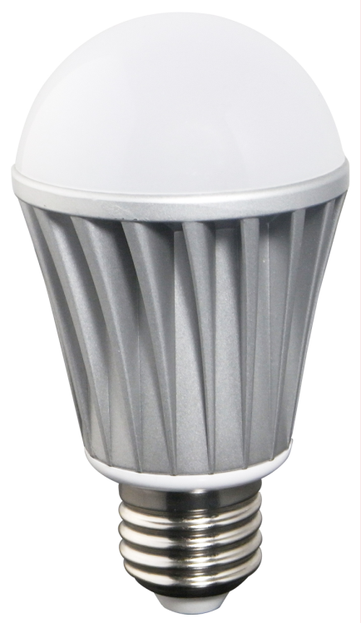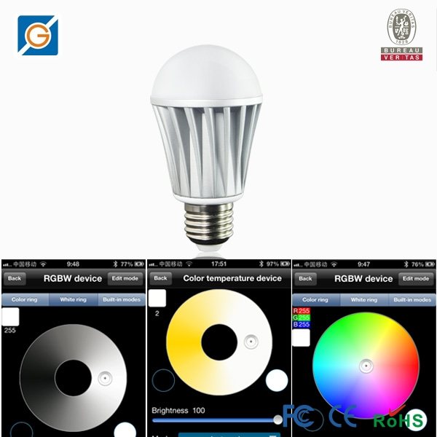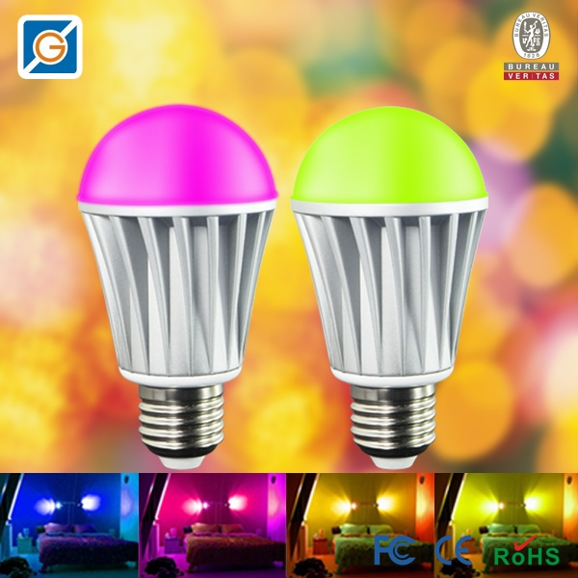

    - Product Summarize：
              - It can achieve remote control ,switch light,adjust brightness and color temperature.There are 16 million colors and dozens of light changing modes.In addition, it do not need additional line,conveniently installed and used.
              - It is a high capability and easily replaceable LED bulb.Certainly,it have other advantages,such as light source is LED,power consumption is just 20% of traditional incandescent,working life is 10 times of traditional save-power light,safe and stable.
              - The case adopts aluminum fins,which can let air backflow cyclically.This design resolved high-powered LED thermal problems in highest degree.Bulb is made of graced poly materials with high transmitacnce 85% or above,and luminous is uniformity.It controlled by wireless WiFi ,furthest remoted distance catch up to 50m.It enjoys low power-consumption ,great anti-jam capacibity,high transmission speed.It can keep light memory(when restart,it will auto keep previous status before shutdown). In addition ,it will turn on in default when energized.This function avoid this situation that you cann’t turn on light when phone were lost.
              - It can be used widely in bedroom ,living room ,entertaining place and operating atmosphere etc.

Technical Parameter
Conection Methods | wifi
Suitable Phone OS | For Android OS,support Android 2.3 or above;For IOS,support IOS5.0 or above
Software language | English/Chinese/German
Channels | 4（RGBW）
Chips Specification | RGB：5050-1.5W*5, Warm White：2835*10
Light Luminous Flux | Red: 45-75LM, Green: 100-150 LM  Blue: 20-50LM, Warm White:400-550LM
Wavelength | Red: 620-630nm Green: 520-525nm Blue: 450-460nm
White Color Temperature | 3000K-3200K
Emitting Angle | 120°
Working Voltage | AC85V-AC240V 50/60Hz
Power | RGB:<7W，Warm White:<6.5W
Power Factor | 0.6
Working Temperature | -25℃-55℃
Effective Romoted Distance | No barrier,40m ;Indoor, 20m
Bulb Material | Milk white PMMA
N.W | 94g
G.W | 110g
Waterproof | IP 25
Bulb Size | D:58.5mm H:109mm

Software
    - Android Software：
Name | LED Magic Color
Running OS | Android 2.3 or above,request device have WiFi function
Install App | Visit “Google Play”,search “ LED Magic Color”,then download and install it.
Software Size | 1.1M
Language | Chinese/English /Germany, automatic recognize language according to OS.

    - IOS Software：
Name | LED Magic Color
Running OS | IOS5.0 or above,such as iPhone, iPad, and iPod touch device.
Install App | Visit App Store,search”LED Magic Color”, then download and install it
Software Size | 2.1 MB
Language | Chinese/English /Germany, automatic recognize language according to OS.
Category | communication

Software User Manual for Android

Installation instructions
- Download it free by Google Play：
Entre “Google play” app store,search ”LED Magic Color”,find ”LED Magic Color Controller v2”,then download it；
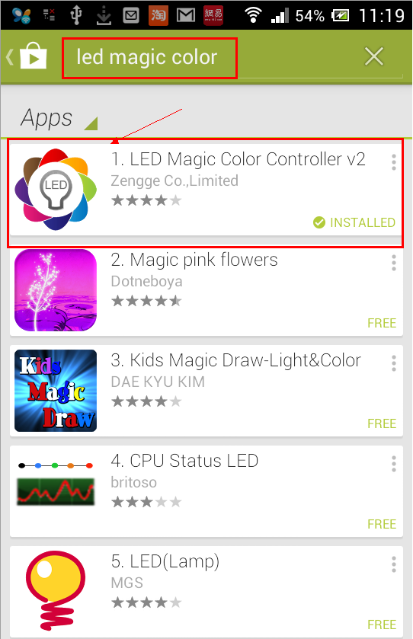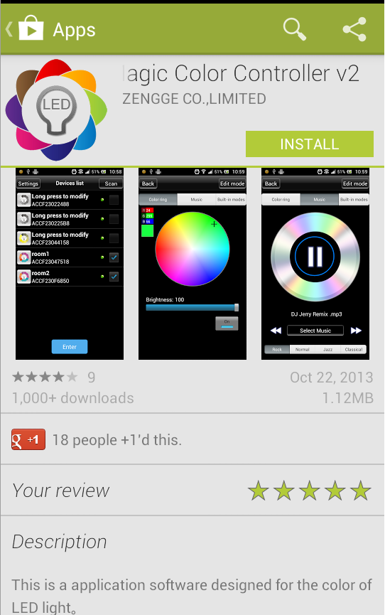
- Install by QR code：
Open QR codesoftware ,then scan following QR code,then download and install it .
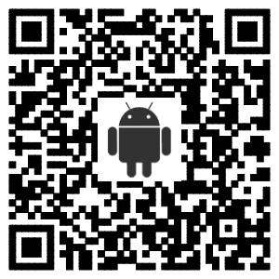
QR code site: http://www.ledmagical.com/Apps/APK/LEDWifiMagicColor.apk
- Install by CD files:
Open CD catalog :Android Software\ LED Magic Color V2.1.0 CN(EN).apk,
You can find “LED Magic Color V2.1.0 CN(EN).apk” installation program 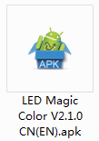 (different phone shows different icon).Pls copy it to phone or connect phone to computer,then click LED Magic Color V2.1.0 CN(EN).apk to install it until finished。

WIFI Connection Setting
Entre to WiFi setting interface,click WLAN”LEDnet*********”,then input password “88888888”.As shown in figures :
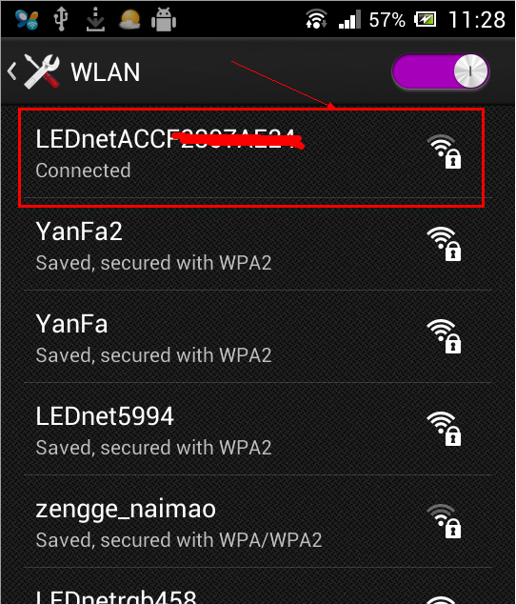 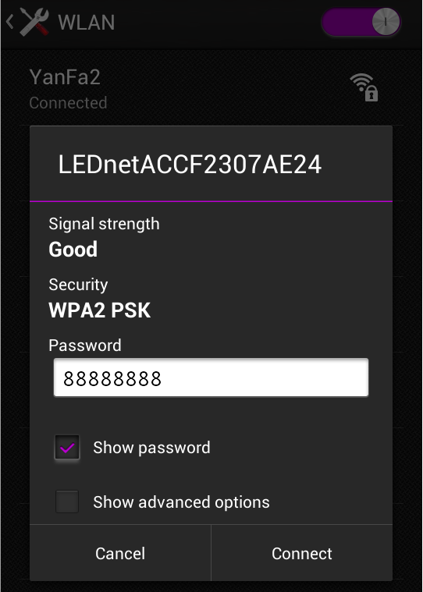

Software Using Guide

Open software：
Click ”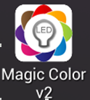” “to open software,then entre to scan interface.If scan successfully,you will find following interface:
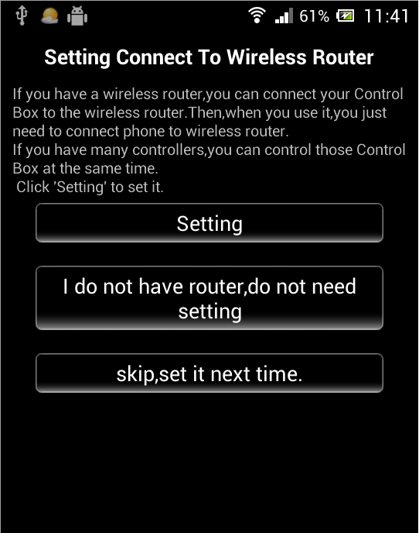  If this is first time you use it,it will shows above interface.It will ask if you want to connect controller to router or not .  You can skip it by click “skip,set it next time”,or click “Setting” to connect controller to router.  About operating instruction,pls refer to chapter”4.04 How Connect Controller to Router” | 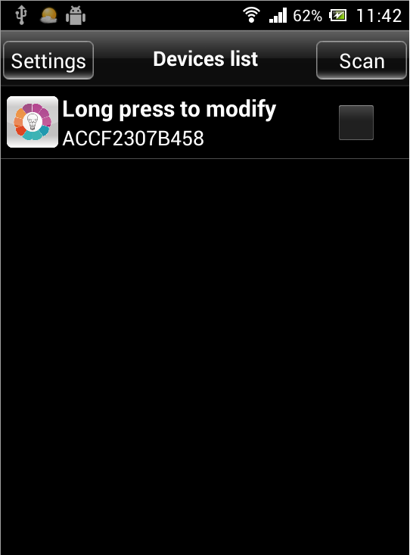  If this is not first time you use it,it will shows above interface.  Notice:if it shows no device when running (the list is empty),it maybe caused by you haven’t connected phone’s WiFi to controller.  Pls refer to “ 4.02 WiFi Connection Setting” to set it .

RGBW 4 colors controller apply interface：
- Color ring function：
Choose any color what you like by click it in color ring.
Click “yellow round button” to adjust warm color.
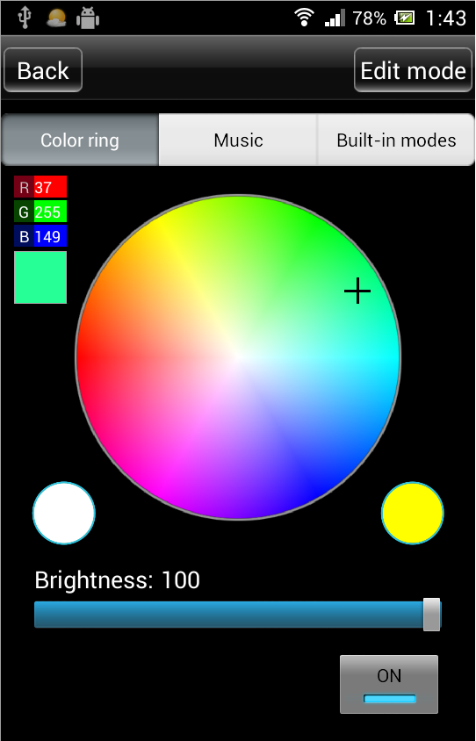 （click color what you want）
- Music control function:
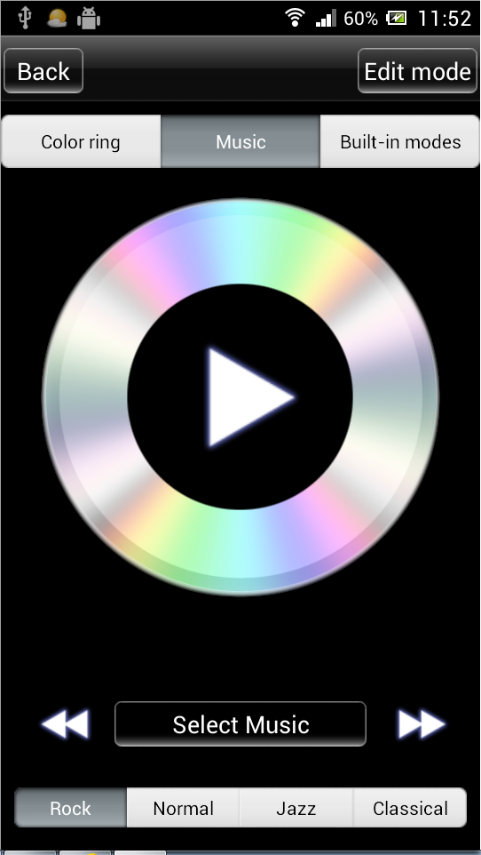 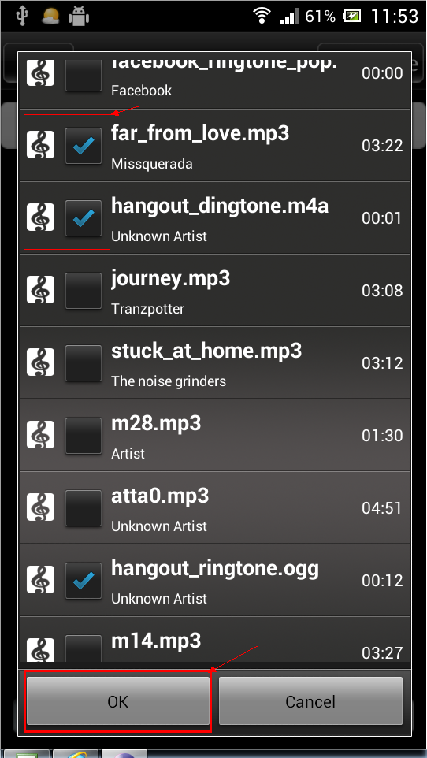 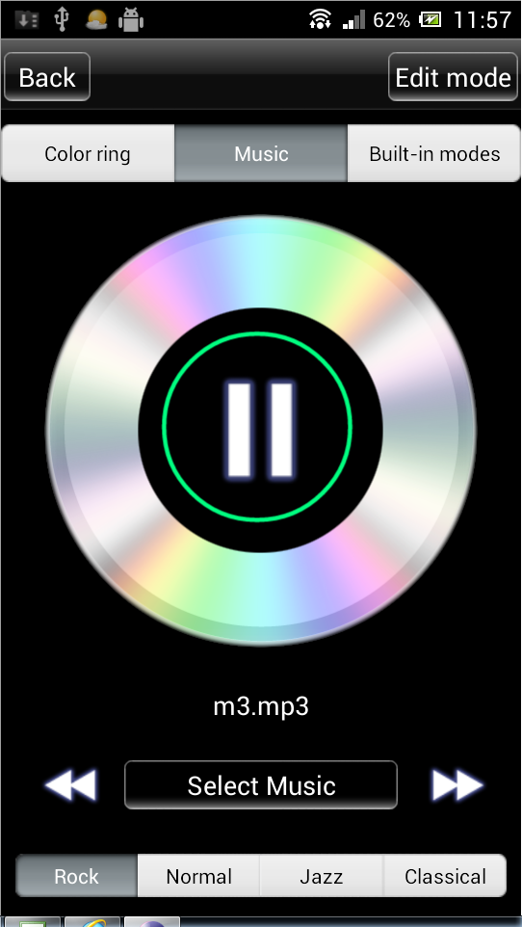
- Built-in dynamic mode function :
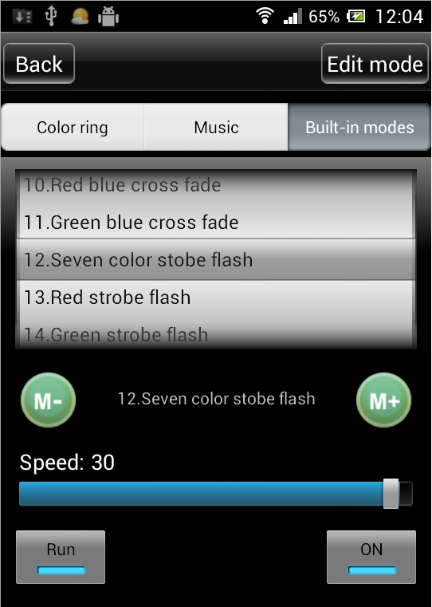 （Notice :scroll it to choose different modes）
- Custom mode function：
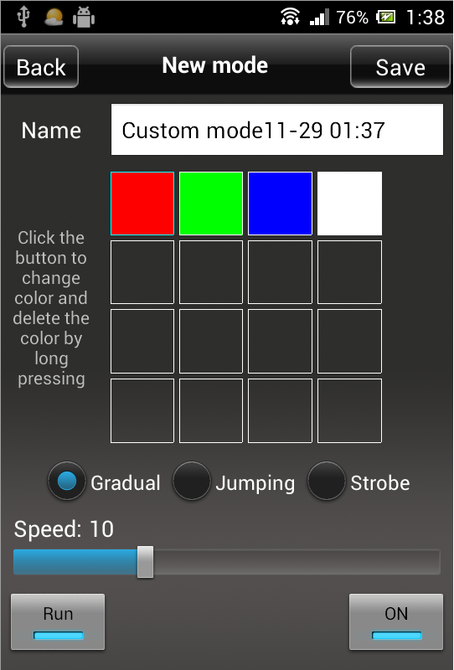 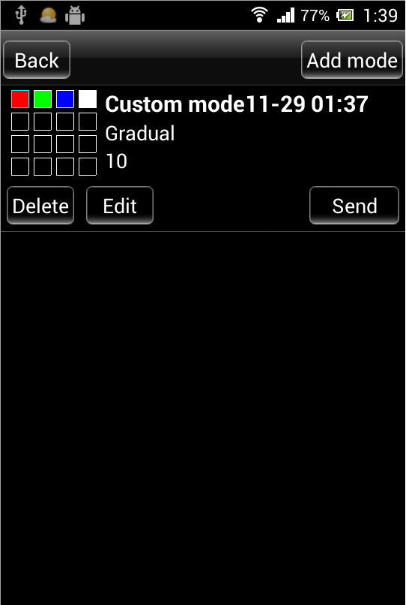

How Connect Controller to Router
First Step:Click ”Settings” to entre to setting interface. | 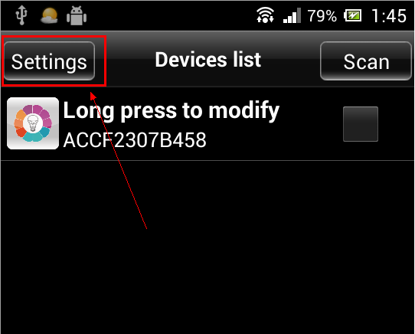
Second Step:Choose right device. | 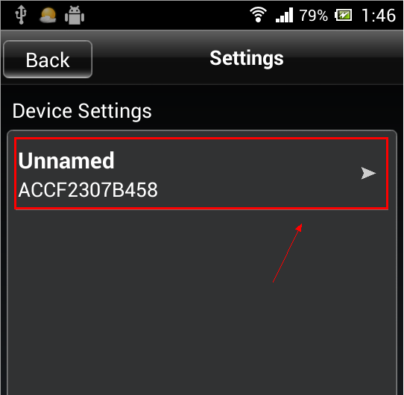
Third step:Choose “Link to Wireless Router” in network mode. | 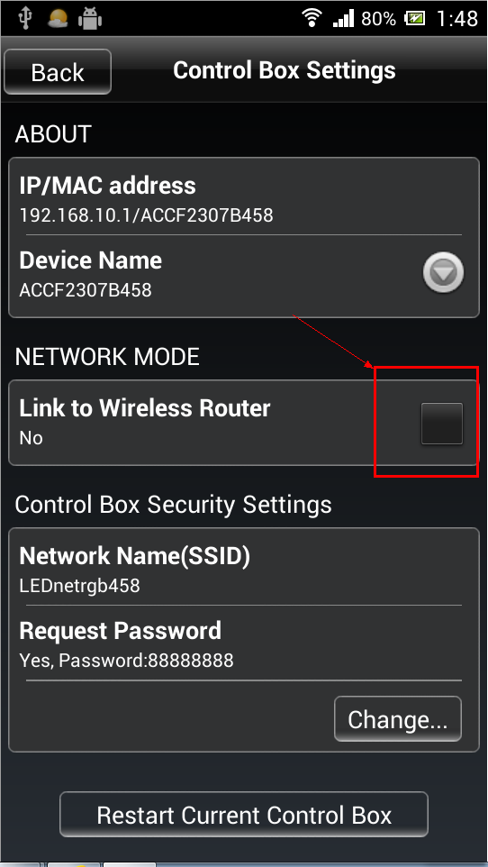
Fourth step:Click right router ,then input router’s password. | 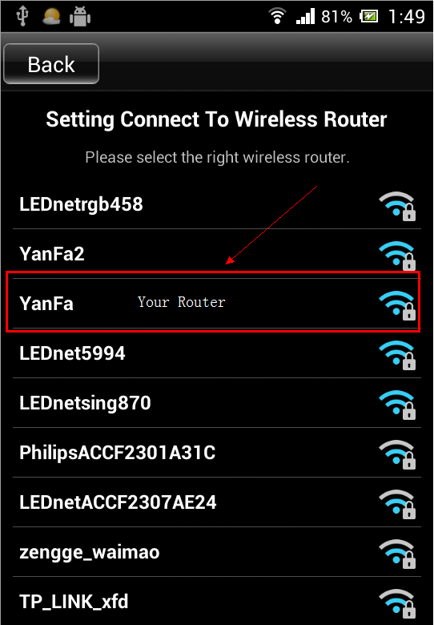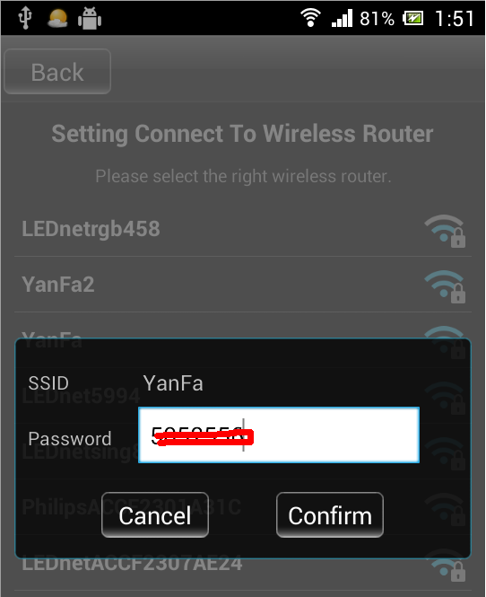
Fifth step:Waiting “The Control Box is restarting ,pls wait …”.  If above operating was successful,it will shows that interface “The Control Box is restarting ,pls wait …” ,you just need to wait dozen seconds . | 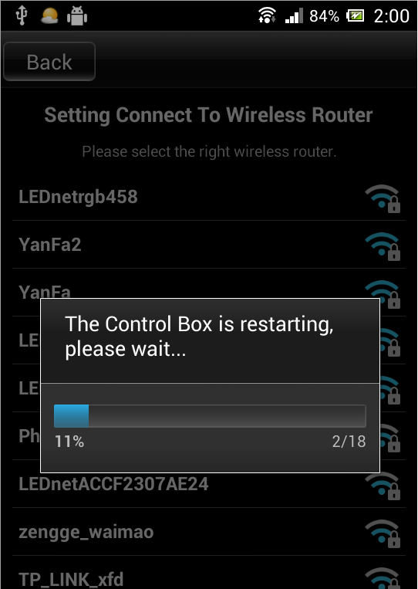
Sixth step:Connect phone to router Entre to phone setting interface,then entre to WLAN interface,reconnect your router.Finally,restart app after connected successfully! | 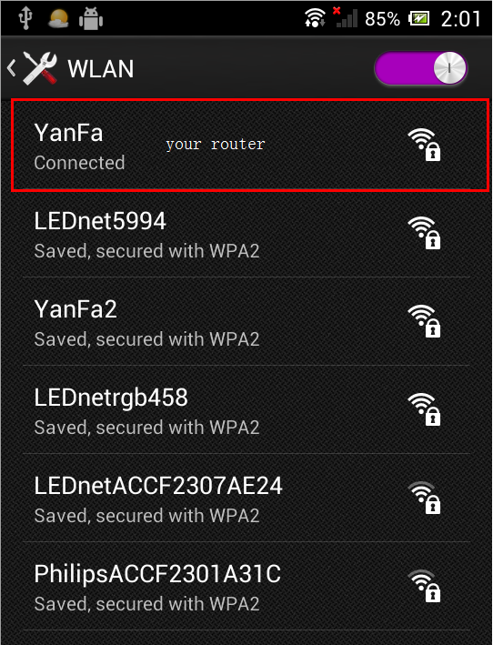
Seventh step:Network mode  If you have a lot of controllers,pls redo above work.Connect all controllers to wireless router,then connect phone ‘s WiFi signal to router.Finally,you can find all controller in app after restarting.  Choose device what you want,then click “Entre” to control multiple devices. | 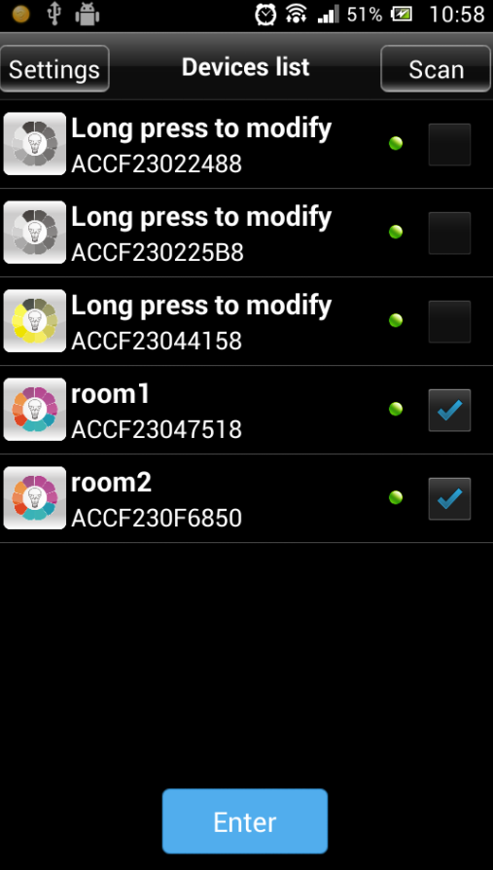

Software User Manual for IOS

Installation Instructions
- 1) Download it free by “App Store”：
Entre to “App Store”,search ”LED Magic Color”,find ”LED Magic Color Controller v2”,then download and install it.
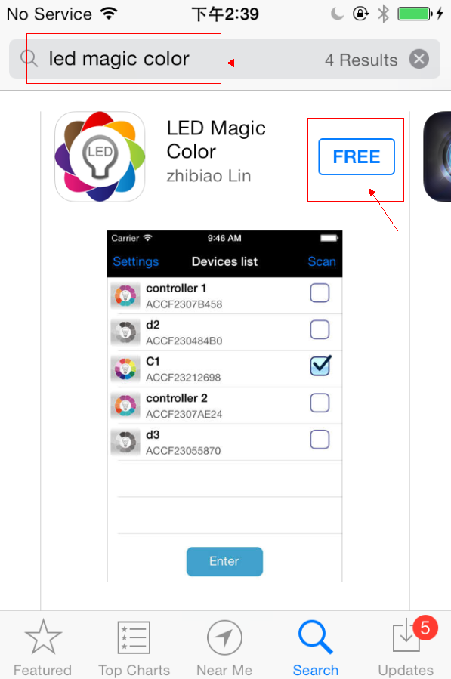
- 2) Install by BQR code and website：
Open BRQ code app ,then scan following BRQ code.Phone will auto shows a site,then download and install it.
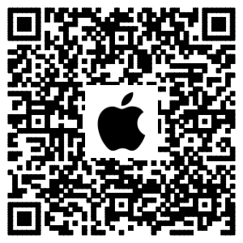
Click following site,phone will auto jumps to “App Store”:
Site: https://itunes.apple.com/us/app/led-magic-color/id595148649?ls=1&mt=8
- Install by CD files(just suitable for phone which can access any Web site)：
Open CD catalog :IOS Software \ LED Magic Color V1.3 CN(EN).ipa,
You can find installation program:LED Magic Color V1.3 CN(EN).ipa,then copy it to phone or connect phone to computer.Click”LED Magic Color V1.3 CN(EN).ipa” to install it.

WIFI Connection Setting
Entre to WiFi setting interface,click WLAN”LEDnet*********”,then input WiFi password: ”88888888”.As shown in figures:
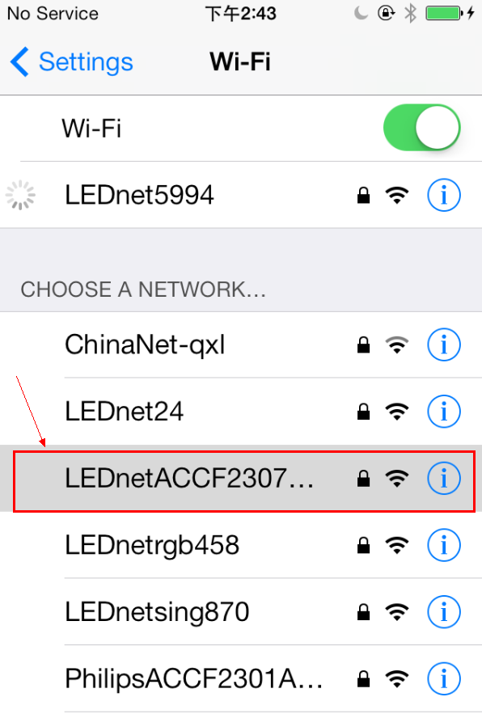 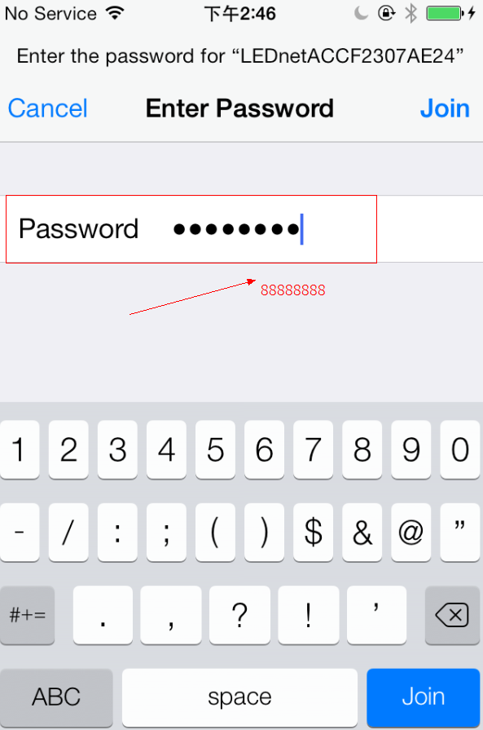

Software Using Guide
Pls refer to software using guide for Android.

How Connect Controller to Router
Pls refer to Android guide chapter “3.04 How Connect Controller to Router”

Answers for Frequently Questions

How to solve it if phone cann’t find bulbs’signal?
Answers:
    - Make sure if bulbs were power on or off;
    - Make sure if phone have opened wifi or not.First time,pls open phone’s wifi setting interface and click “LEDnet*********”to connect it.
    - If step a) and b) were correct,pls run app.Then you can find bulbs.

In phone wifi setting interface,” LEDnet*********” cannot be found.How to do?
Answers:
    - Make sure if bulbs were power on or off;
    - If you have set bulbs to network mode,”LEDnet*********” was concealed.That’s normal.
    - Pls connect phone’s wifi to wireless router.Then run “LED Magic Color” app,devices can be scanned.

Though phone was connected to router successfully,but phone cann’t find wifi signal “LEDnet*********”,how to do?
Answers:
    - Pls try to solve it as following methods:
            - Pls power off bulbs and wireless router.
            - Run wireless router at first,and power on bulbs after 30s.
            - Wait about 2 minutes,run app “LED Magic Color” since phone’s wifi were connected to wireless router.Then check if you can find bulbs’ signal or not.
            - If bulbs still cann’t be scanned,the reason would be that bulbs cann’t be connected to router.You need to restore your bulbs to factory reset.
    - Pls restore bulbs to factory reset,
            - Pls power off bulbs and wireless router.
            - Just power on bulbs(notice:keep wireless router in power-off status)
            - Wait about 2 minutes,phone’s wifi setting interface will shows “LEDnet*********”,click it to connect.
            - After connected successfully,run “LEDMagic Color”,then bulbs should be scanned successfully.Click “Settings” →”ACCF****” → “Restore to factory reset”,then restart bulbs.
            - You can reconnect bulbs to wireless router.

Failed many times,bulbs still can’t be connected to router.How to do?
Answers:
    - Make sure you have input right password of wireless router.
    - Make sure qty that how many device can be accepted to router is still available.Generally,one router can accept 15 pcs wireless device,some routers just accept 7 or 8 pcs wireless device.
    - Try to use other wireless router

